Assignment 5-Ticket Booking System

----------------------------Task 1: Database Design ----------------------------

1. Create the database named "TicketBookingSystem"

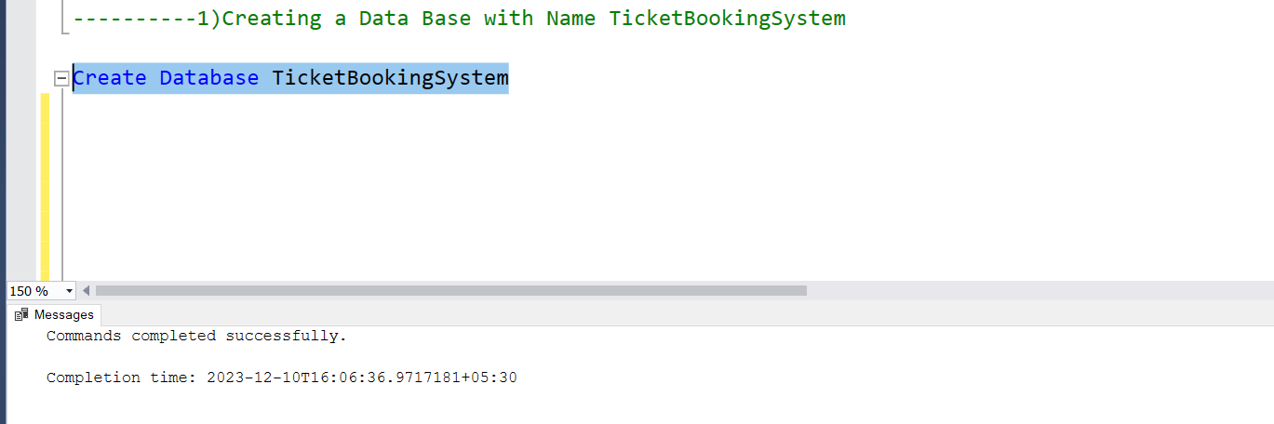

2) Write SQL scripts to create the mentioned tables with appropriate data types, constraints, and relationships.

• Venu • Event • Customers • Booking

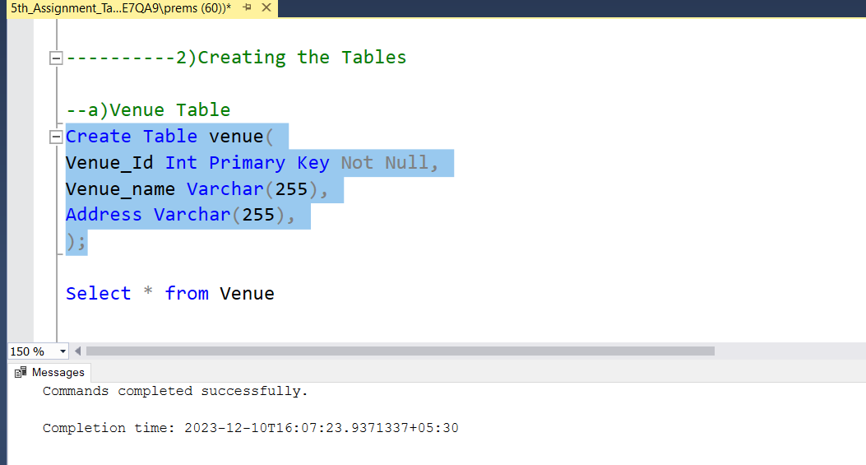

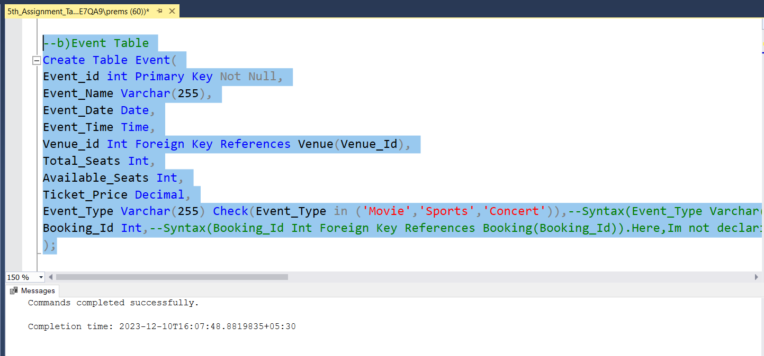

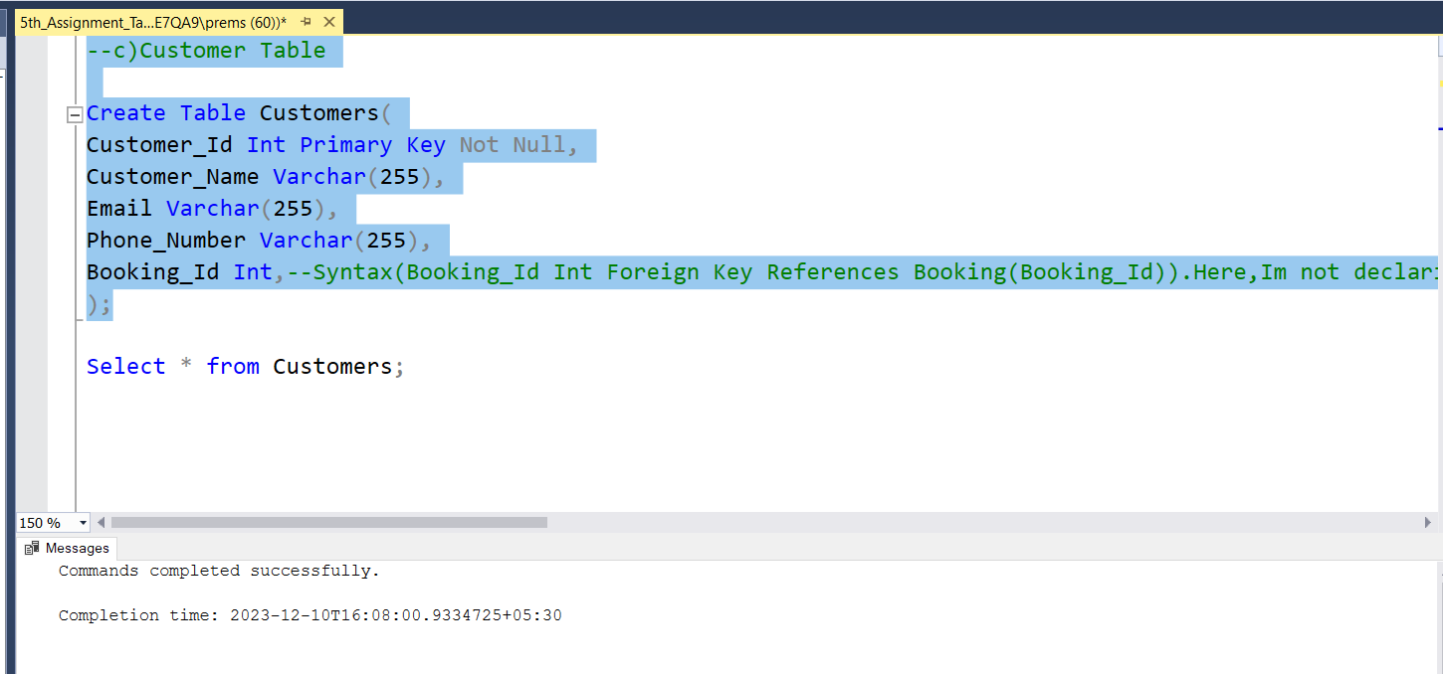

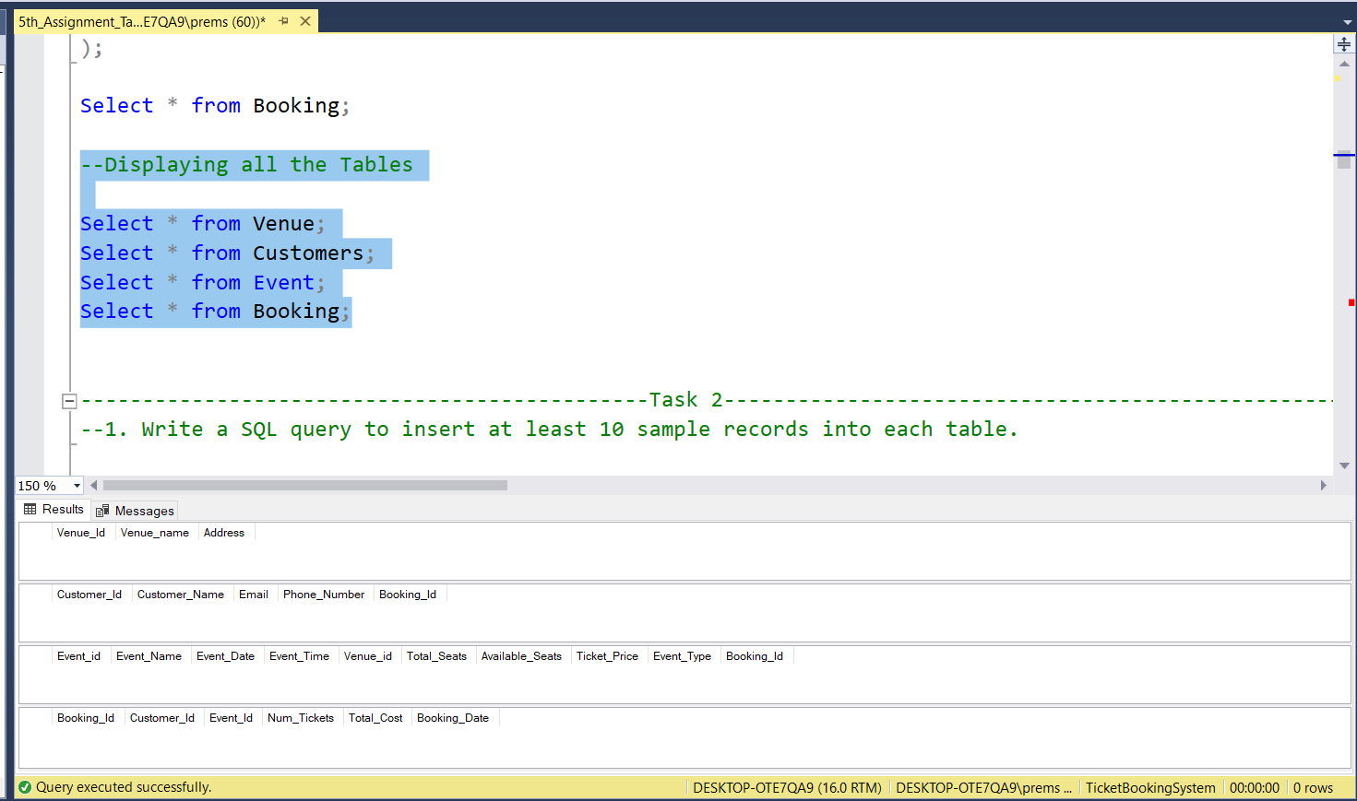

3. Create an ERD (Entity Relationship Diagram) for the database.

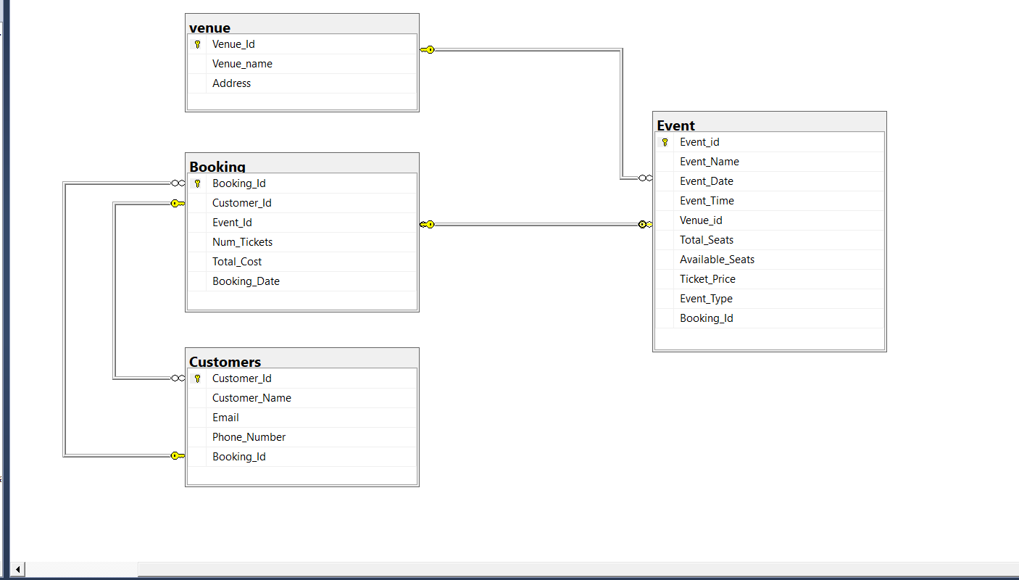

------------------Tasks 2: Select, Where, Between, AND, LIKE: ------------

4)Write a SQL query to insert at least 10 sample records into each table.

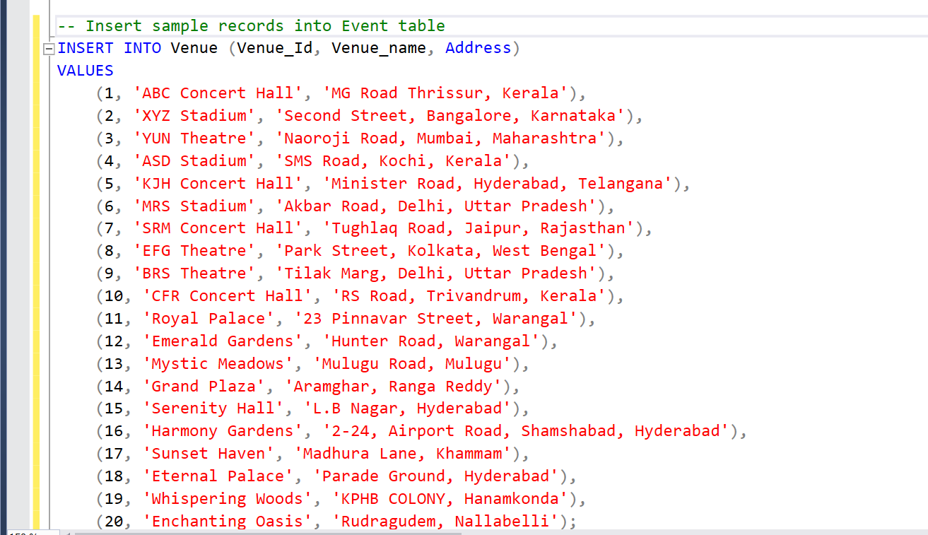

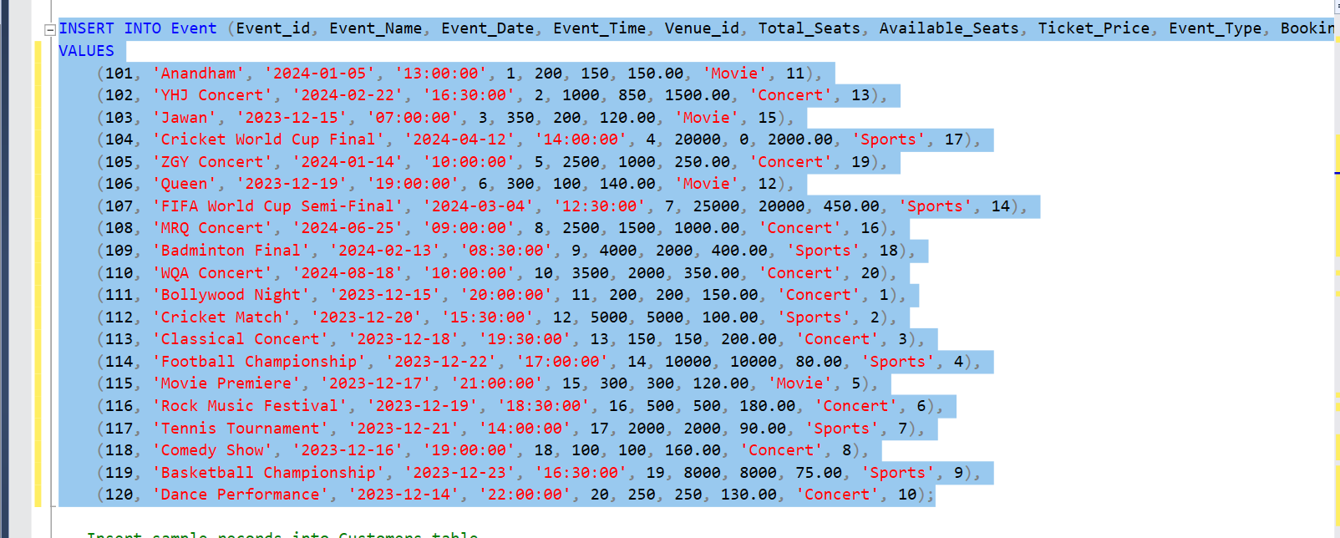

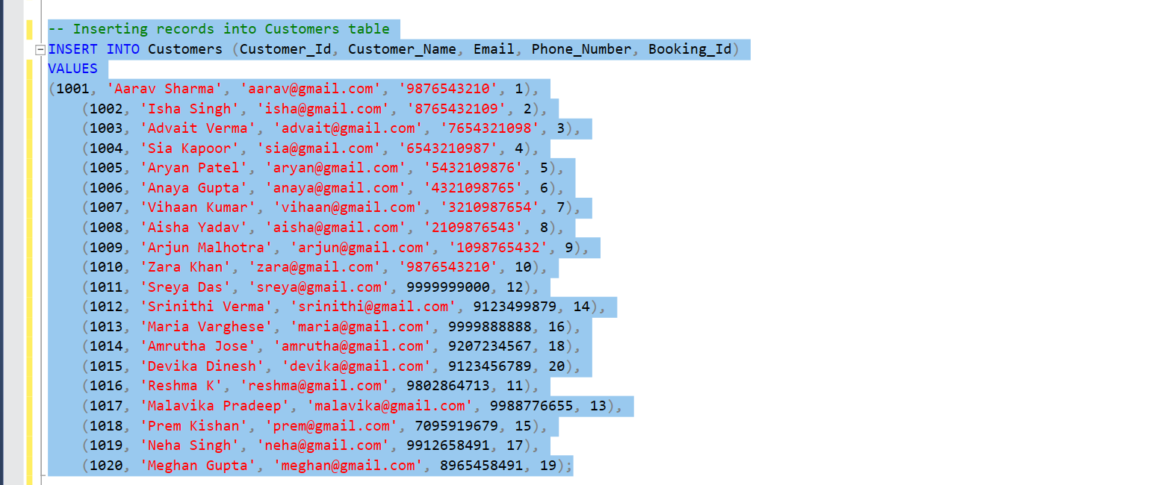

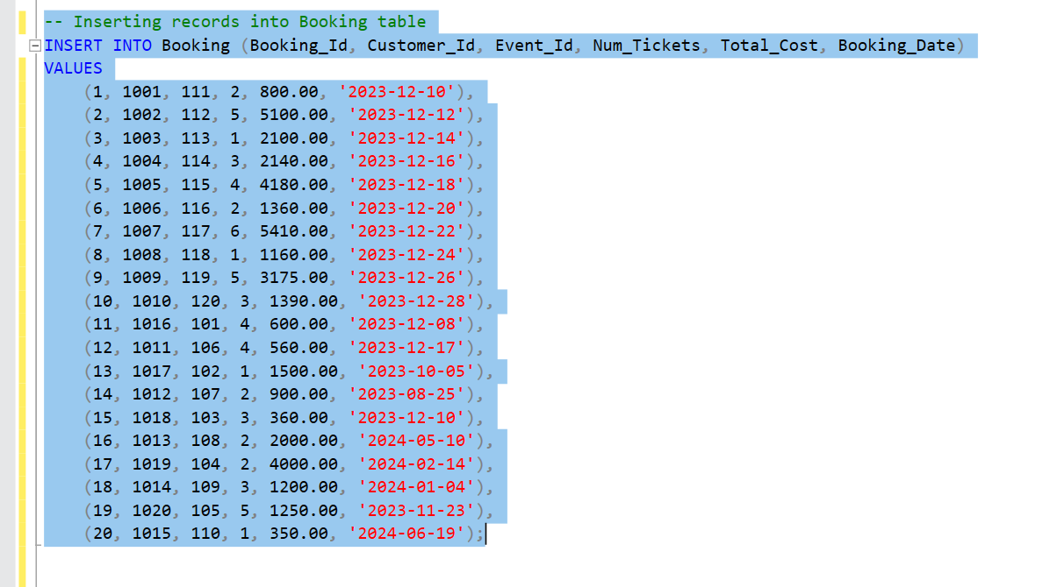

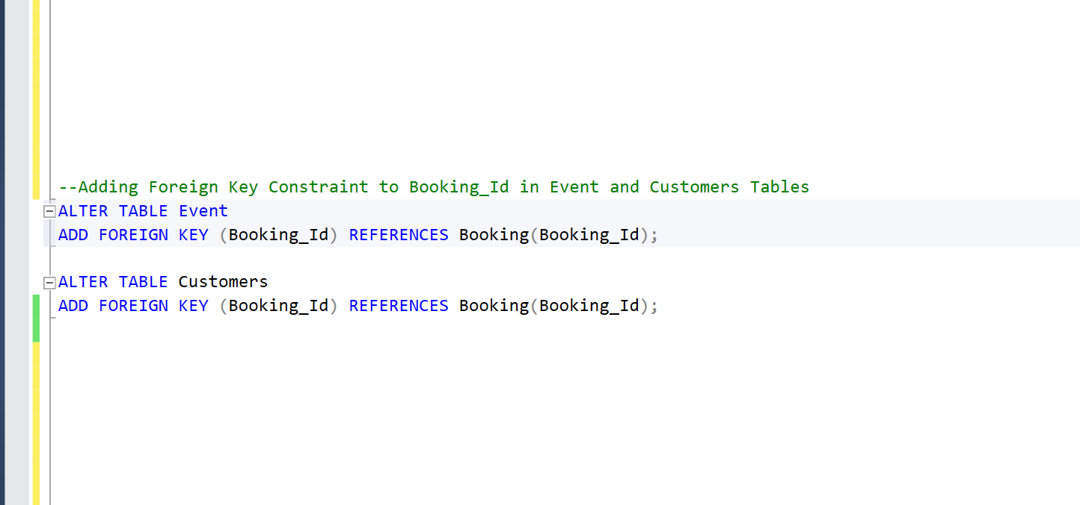

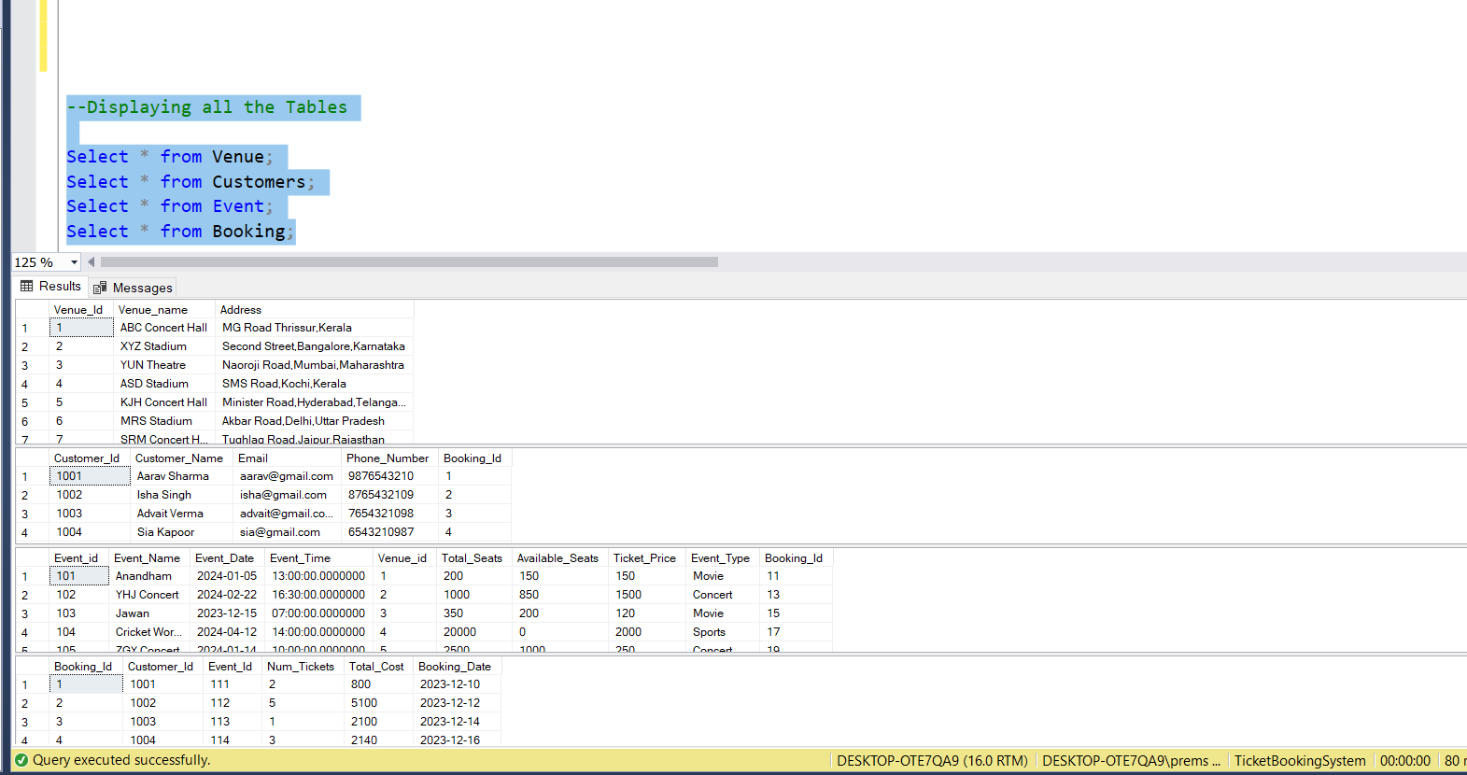

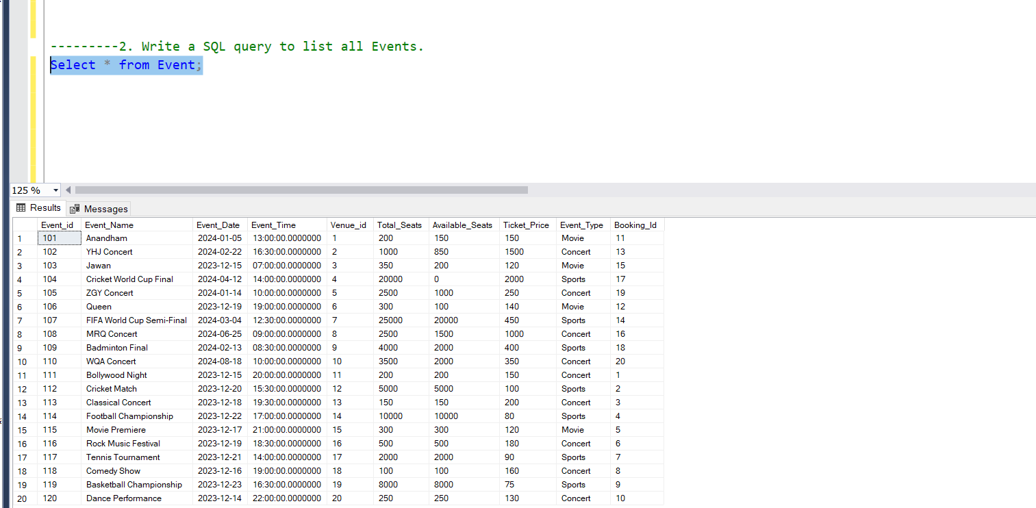5)Write a SQL query to list all Events.

6)Write a SQL query to select events with available tickets.

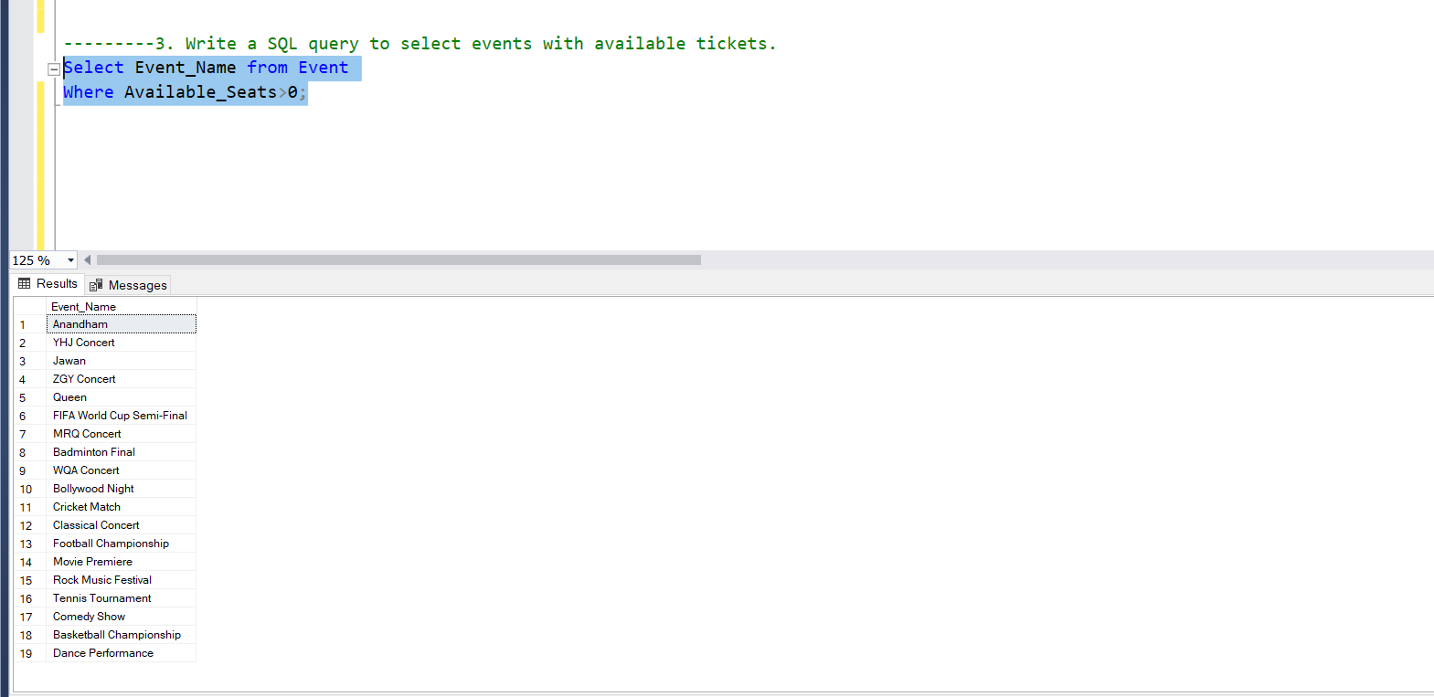

7)Write a SQL query to select events name partial match with ‘cup’.

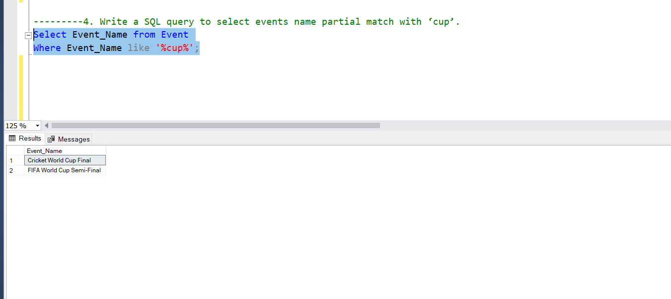

8) Write a SQL query to select events with ticket price range is between 1000 to 2500.

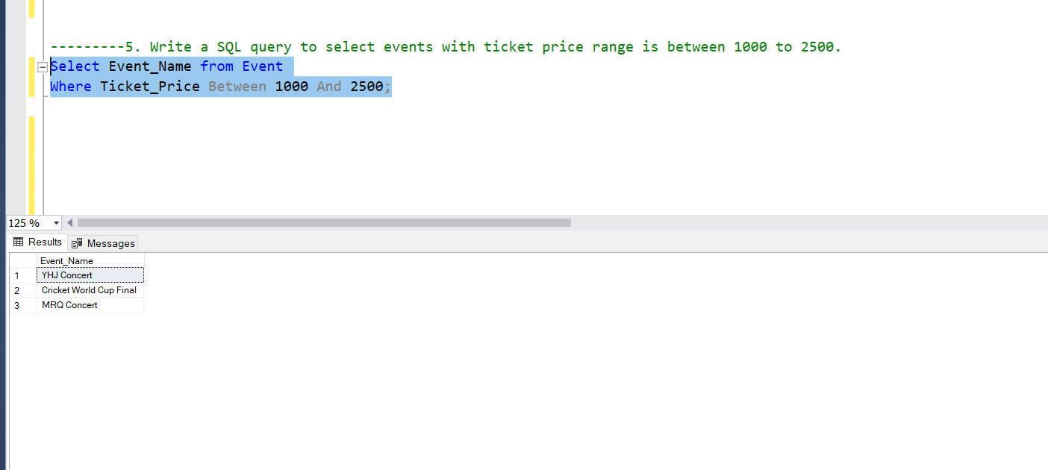

9) Write a SQL query to retrieve events with dates falling within a specific range.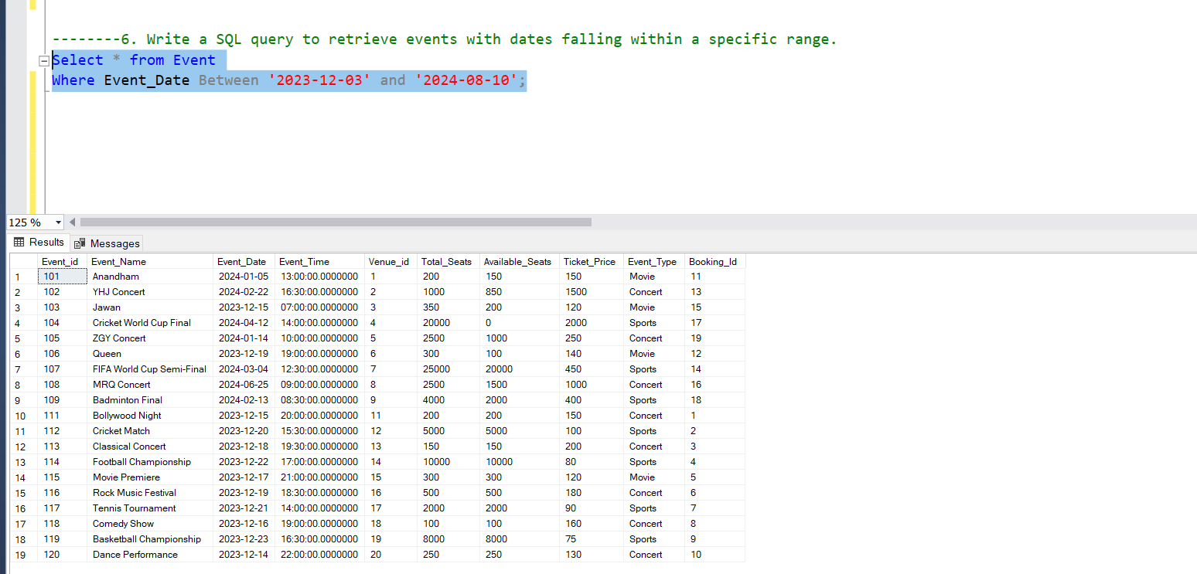

10)Write a SQL query to retrieve events with available tickets that also have "Concert" in their name.

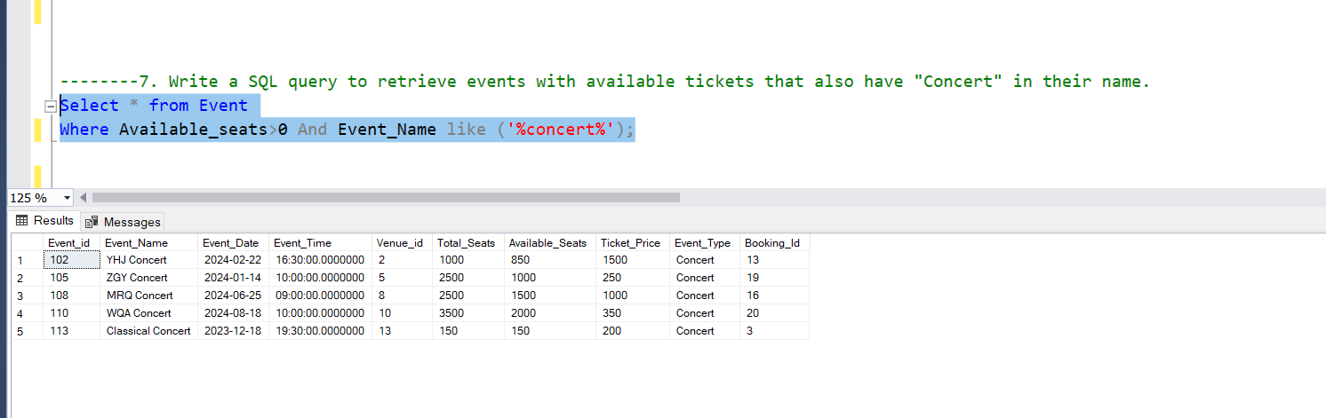

11) Write a SQL query to retrieve bookings details contains booked no of ticket more than 4.

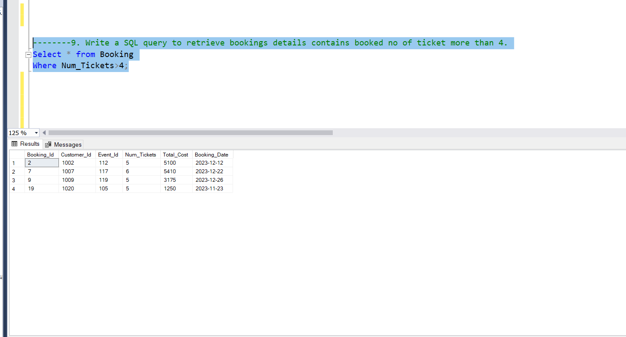

12) Write a SQL query to retrieve customer information whose phone number end with ‘000’.

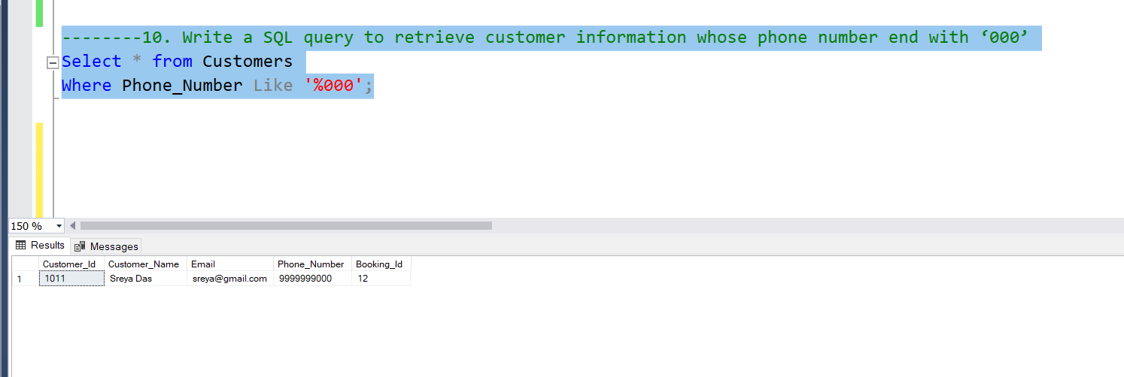

13) Write a SQL query to retrieve the events in order whose seat capacity more than 15000.

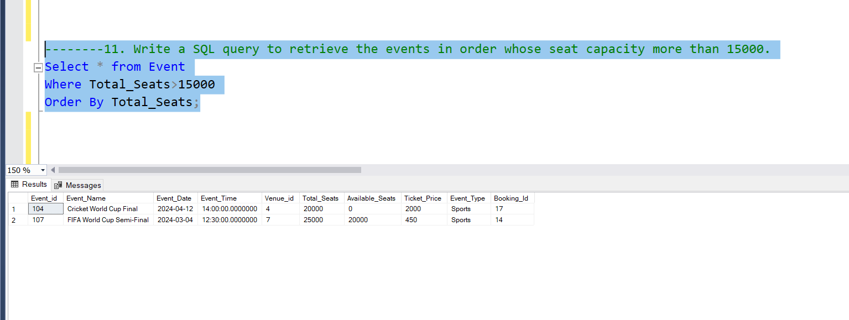

14) Write a SQL query to select events name not start with ‘x’, ‘y’, ‘z’.

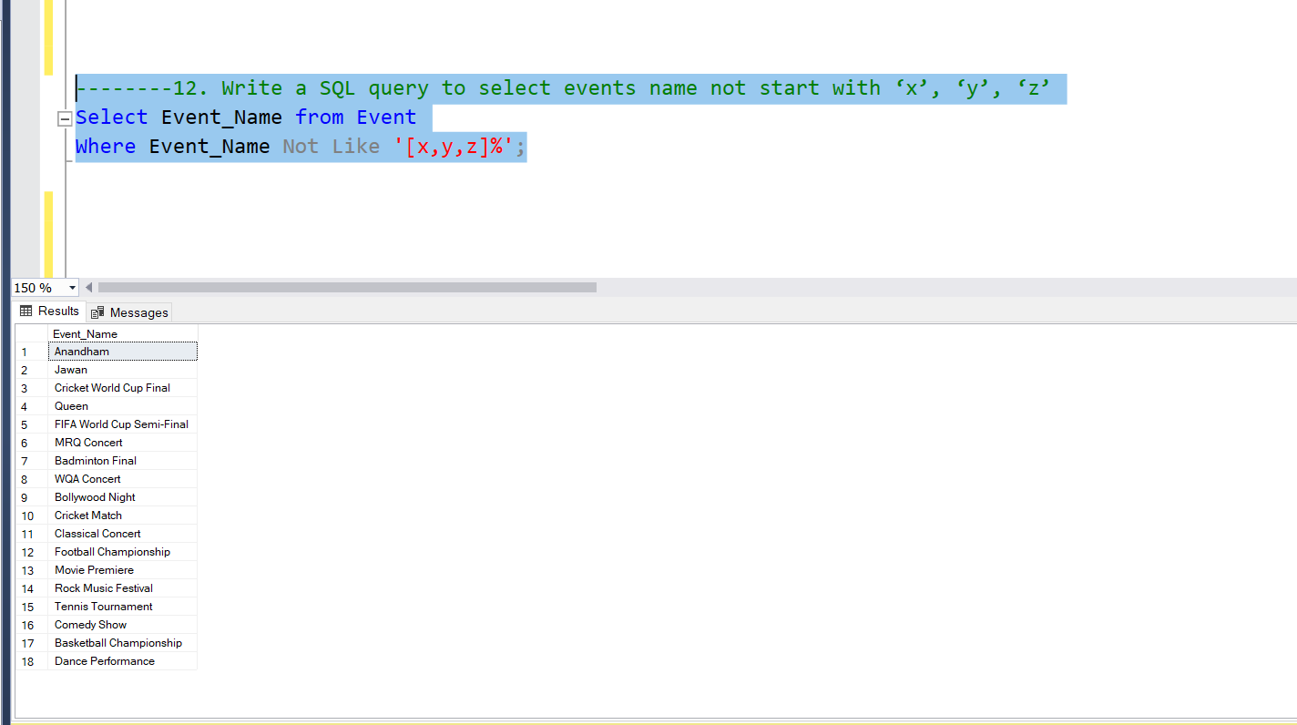

-------------------------------------Tasks 3-----------------------------------------

15)Write a SQL query to List Events and Their Average Ticket Prices.

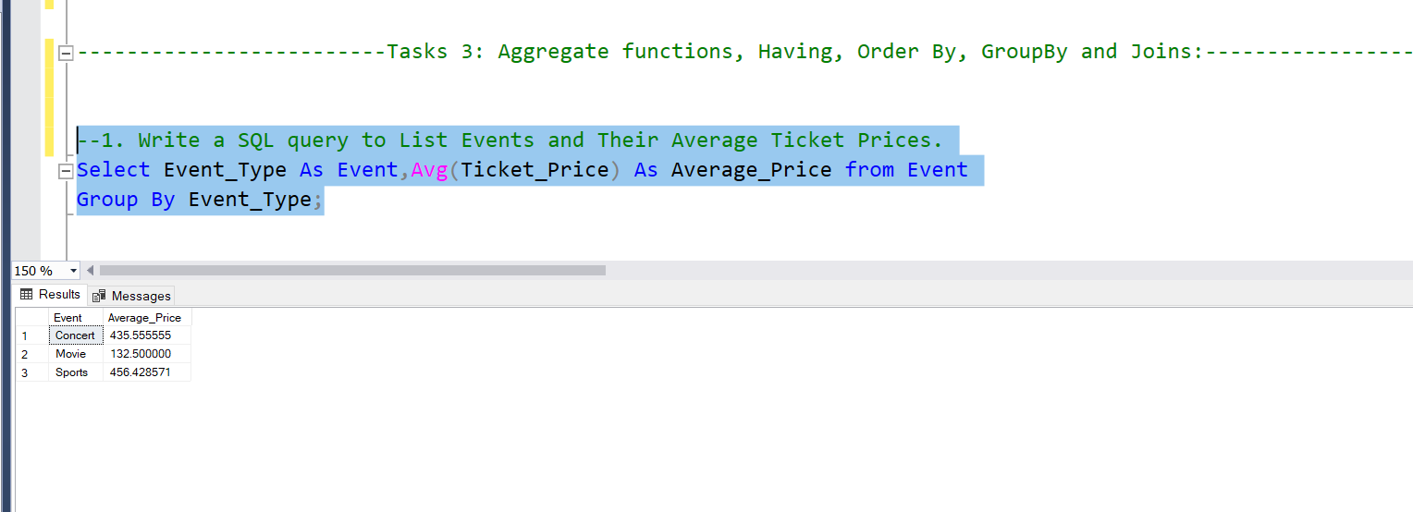

16)Write a SQL query to Calculate the Total Revenue Generated by Events.

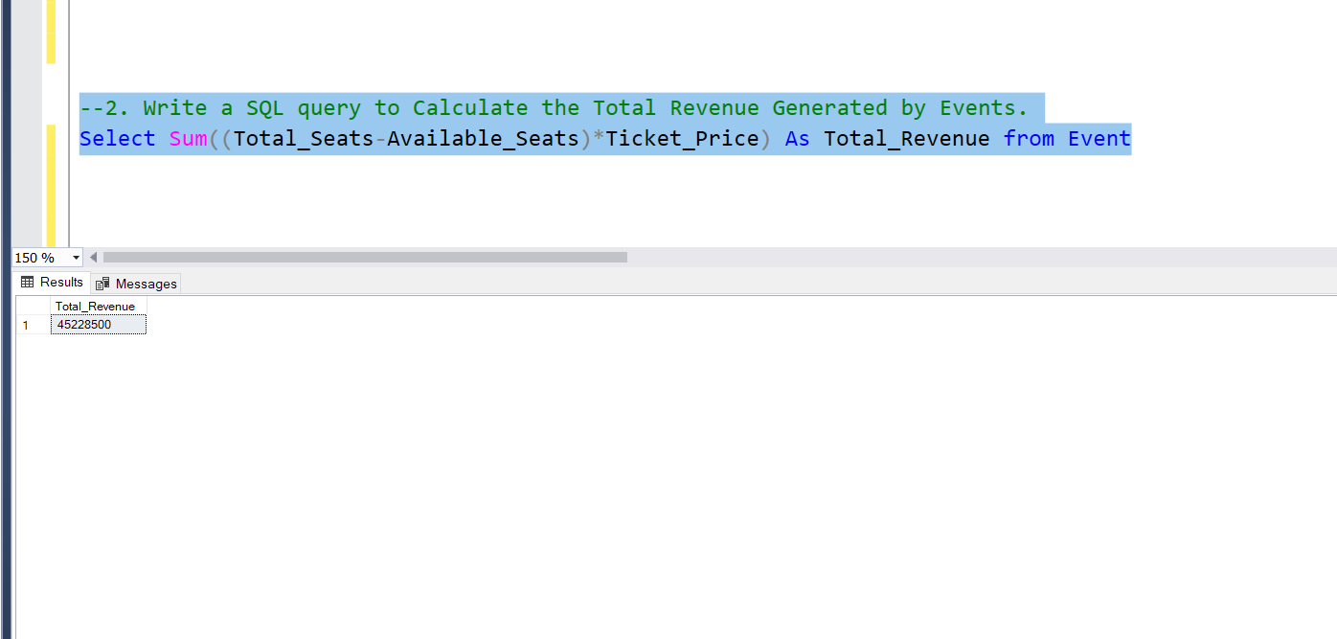

17)Write a SQL query to Calculate the Total Number of Tickets Sold for Each Event.

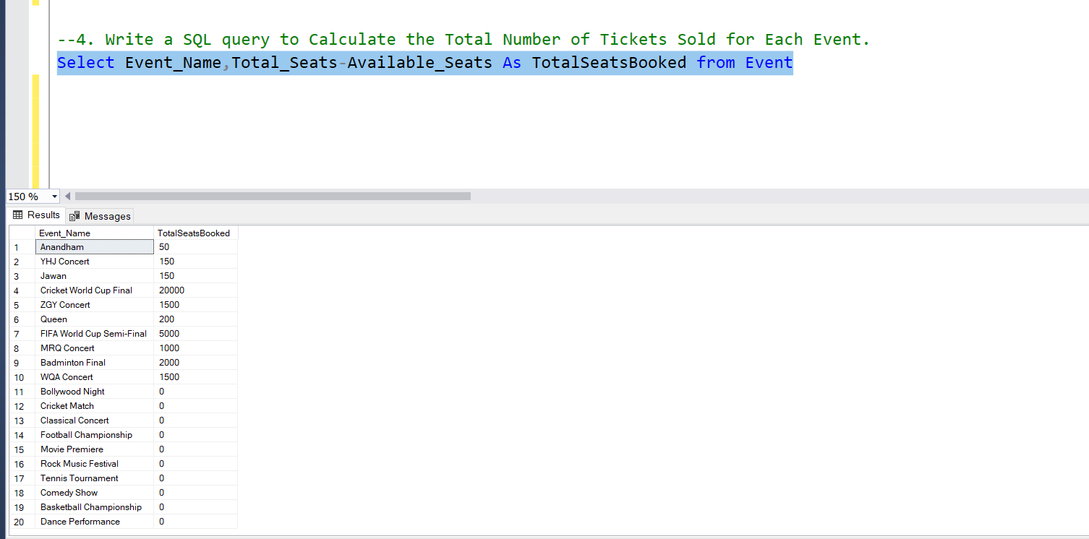

18)Write a SQL query to Find Events with No Ticket Sales.

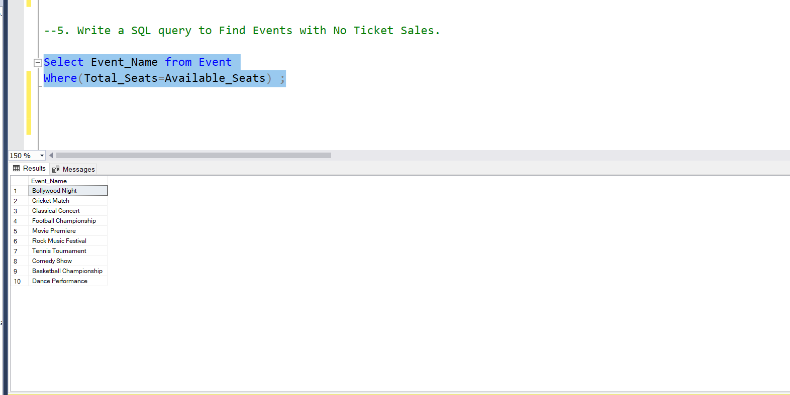

19)Write a SQL query to Find the User Who Has Booked the Most Tickets. 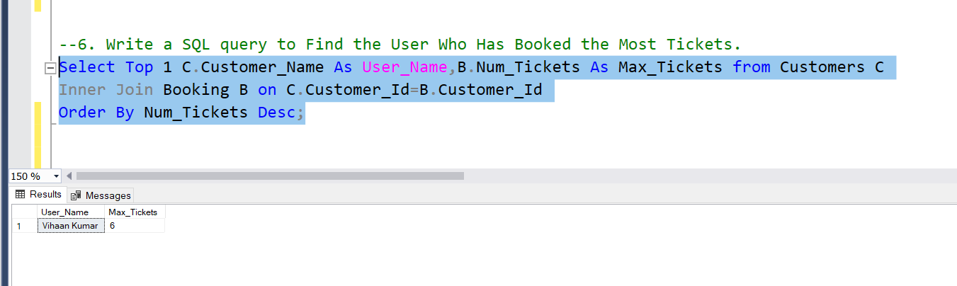

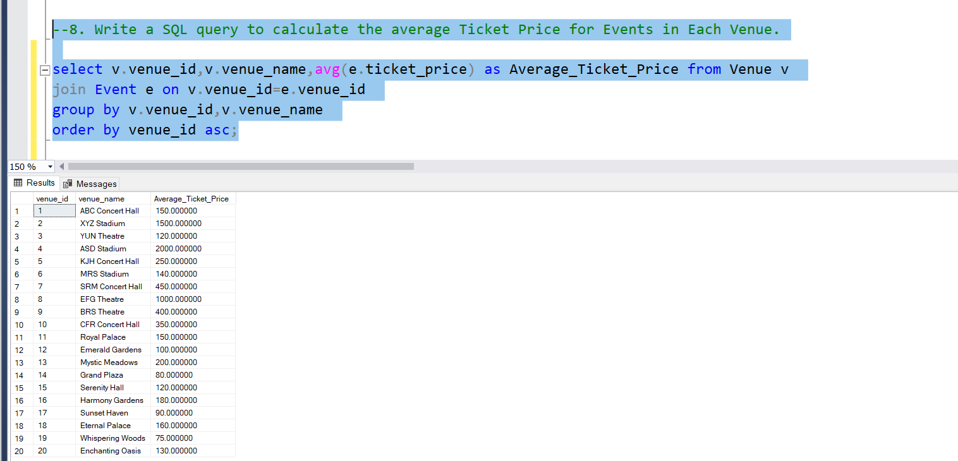20)Write a SQL query to calculate the average Ticket Price for Events in Each Venue

21)Write a SQL query to calculate the total Number of Tickets Sold for Each Event Type.

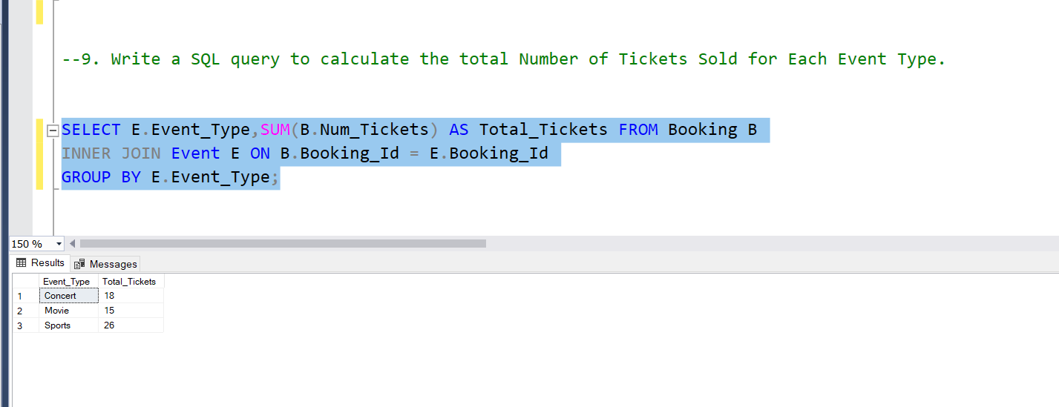

22) Write a SQL query to calculate the total Revenue Generated by Events in Each Year.

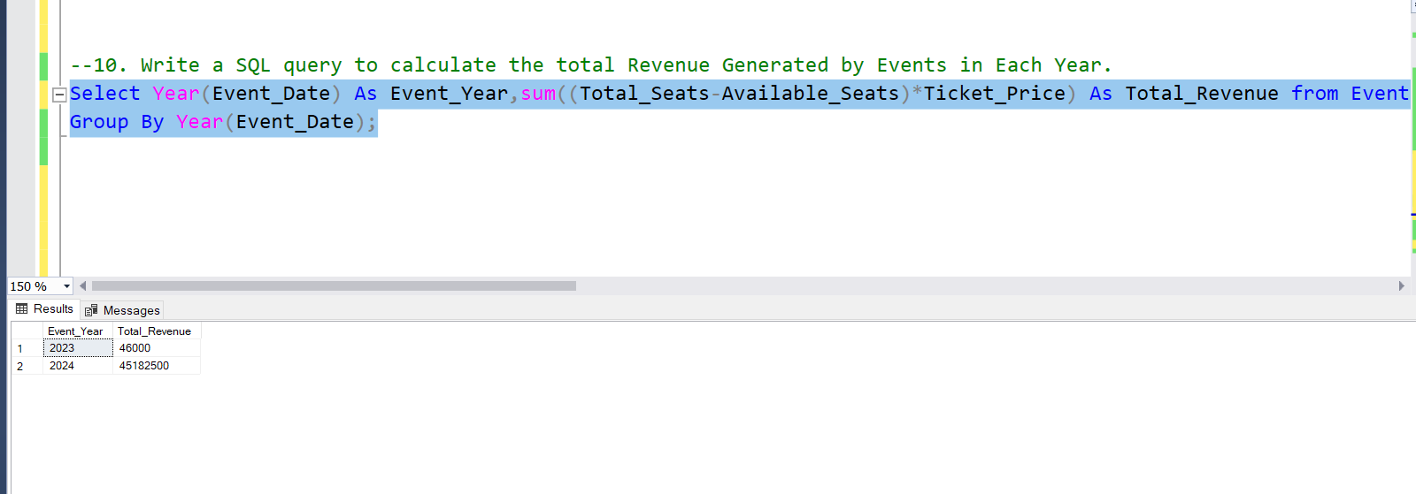

23) Write a SQL query to list users who have booked tickets for multiple events.

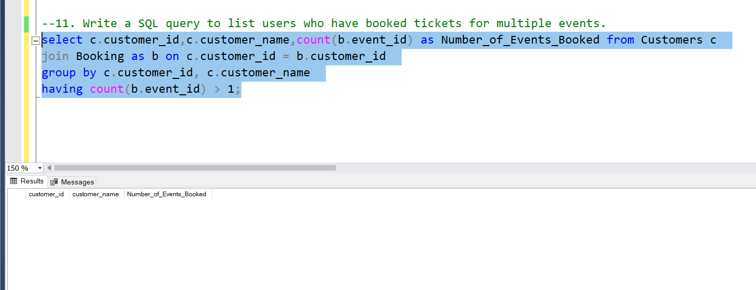

24) Write a SQL query to calculate the Total Revenue Generated by Events for Each User.

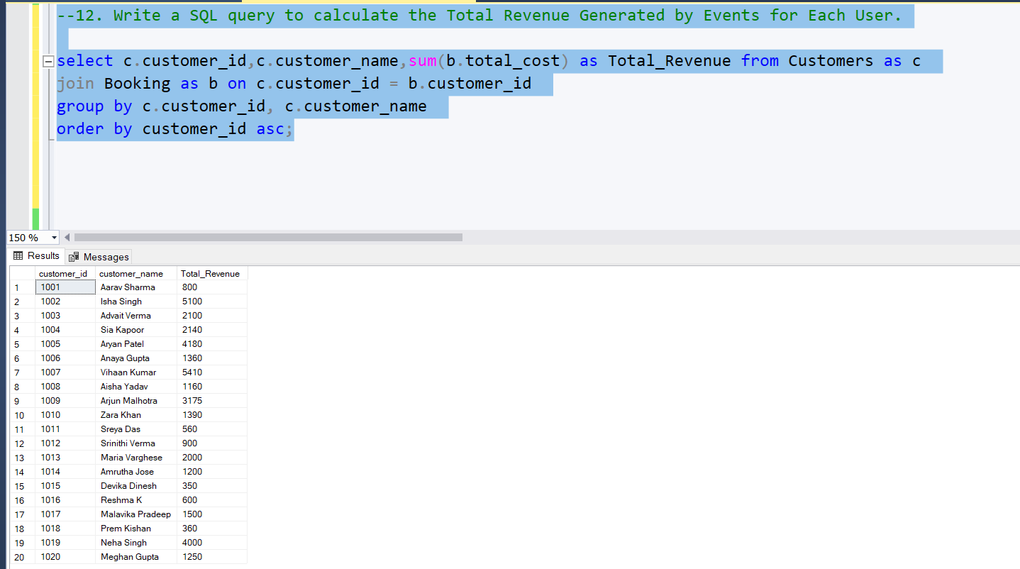

25. Write a SQL query to calculate the Average Ticket Price for Events in Each Category and Venue.

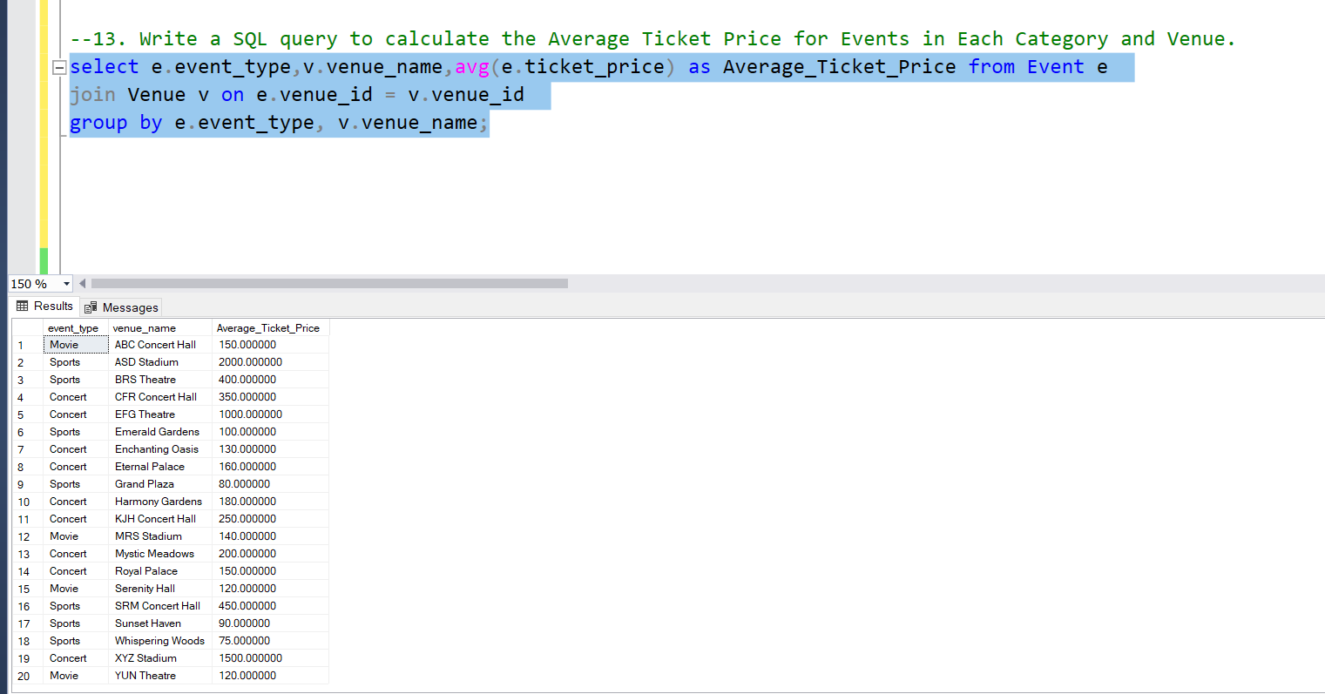

-----------------------------------------TASK 4------------------------------------

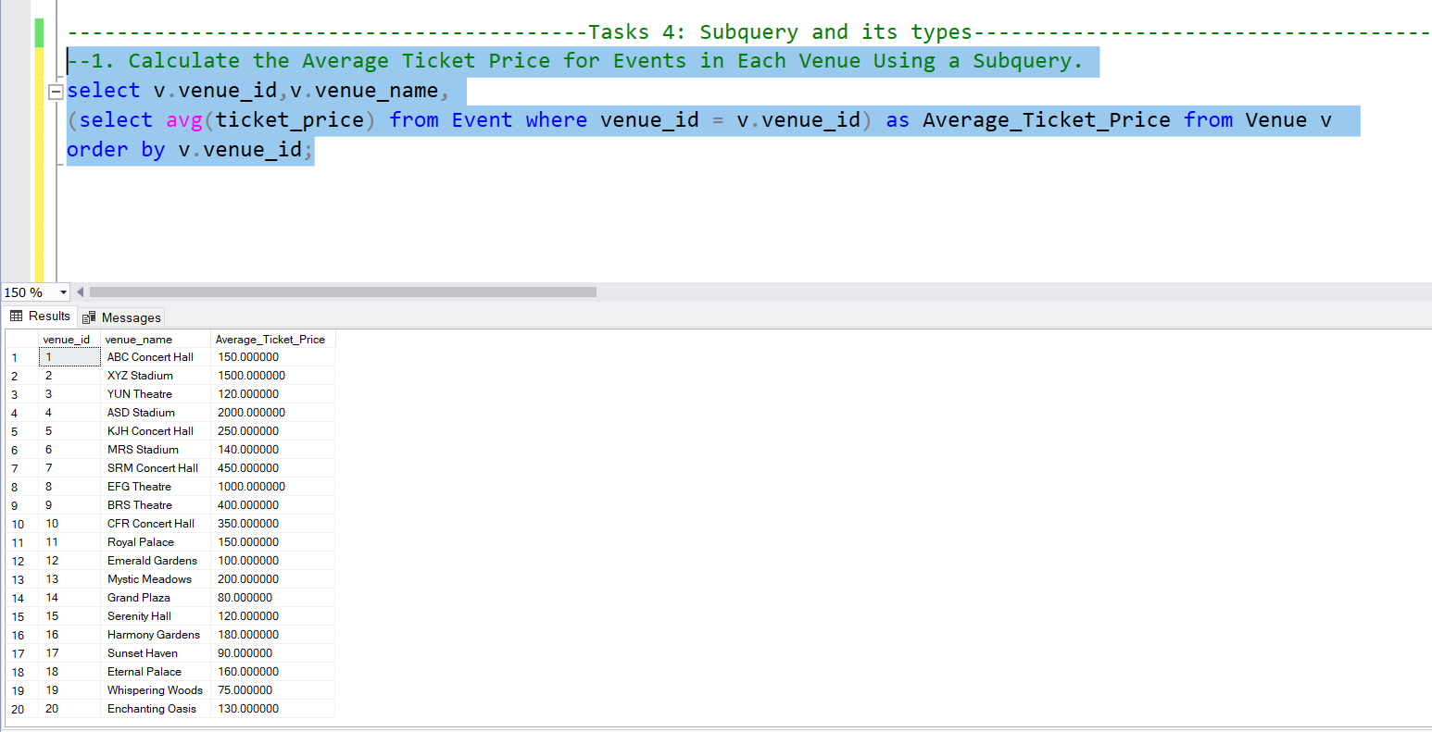26)Calculate the Average Ticket Price for Events in Each Venue Using a Subquery.

27)Find Events with More Than 50% of Tickets Sold using subquery.

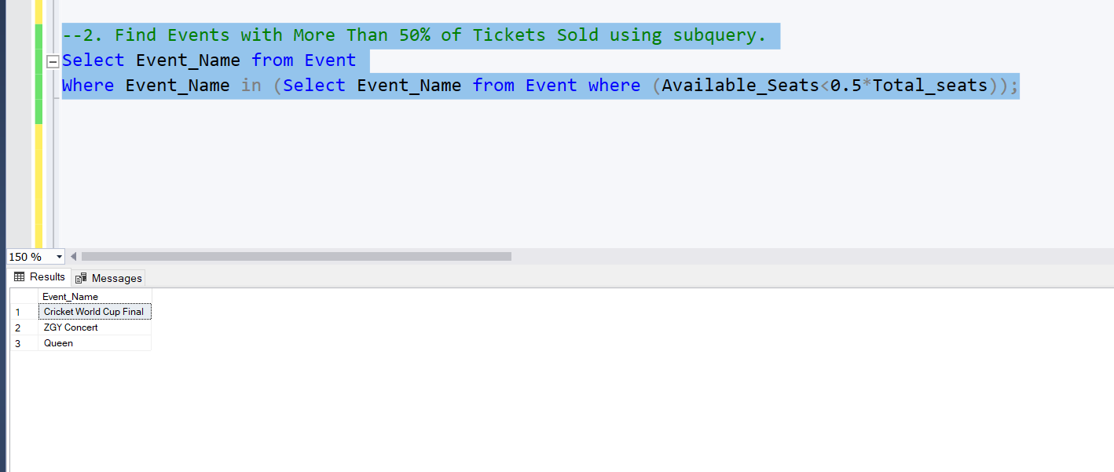

26)Calculate the Total Number of Tickets Sold for Each Event.

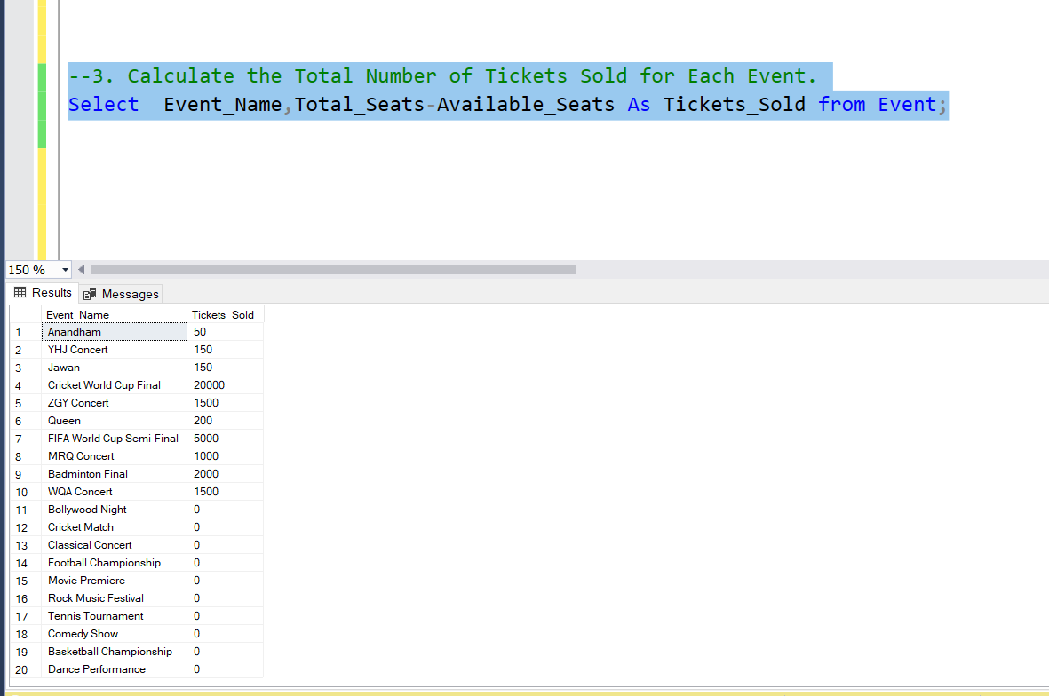

27) . Find Users Who Have Not Booked Any Tickets Using a NOT EXISTS Subquery.

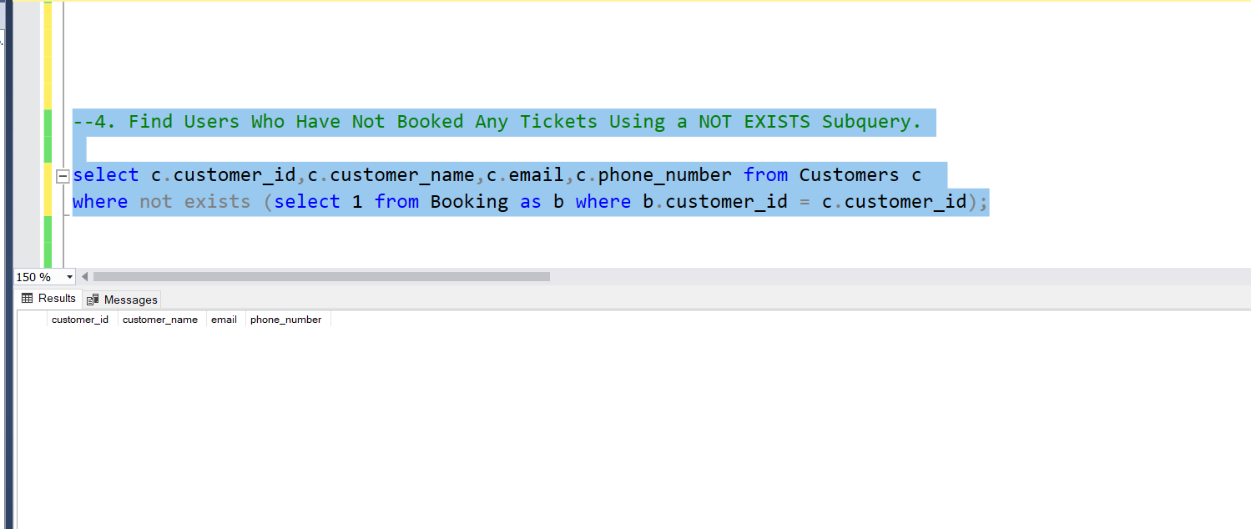

28)List Events with No Ticket Sales Using a NOT IN Subquery.

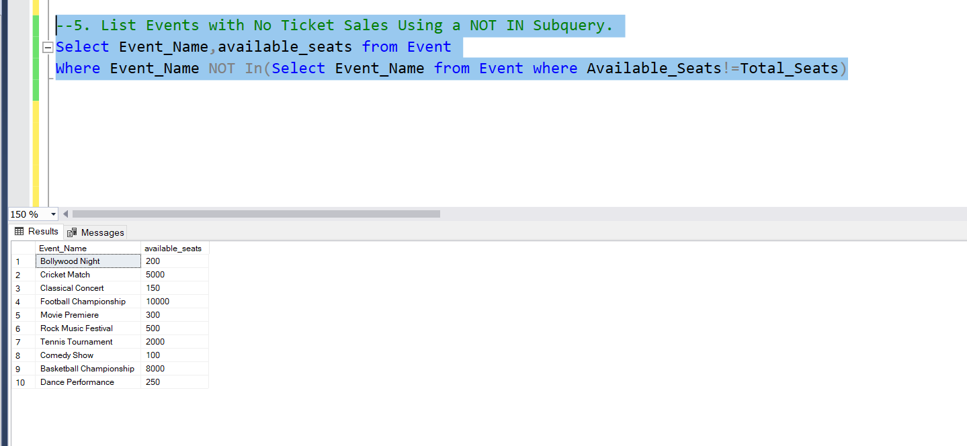

29)Calculate the Total Number of Tickets Sold for Each Event Type Using a Subquery in the FROM Clause.

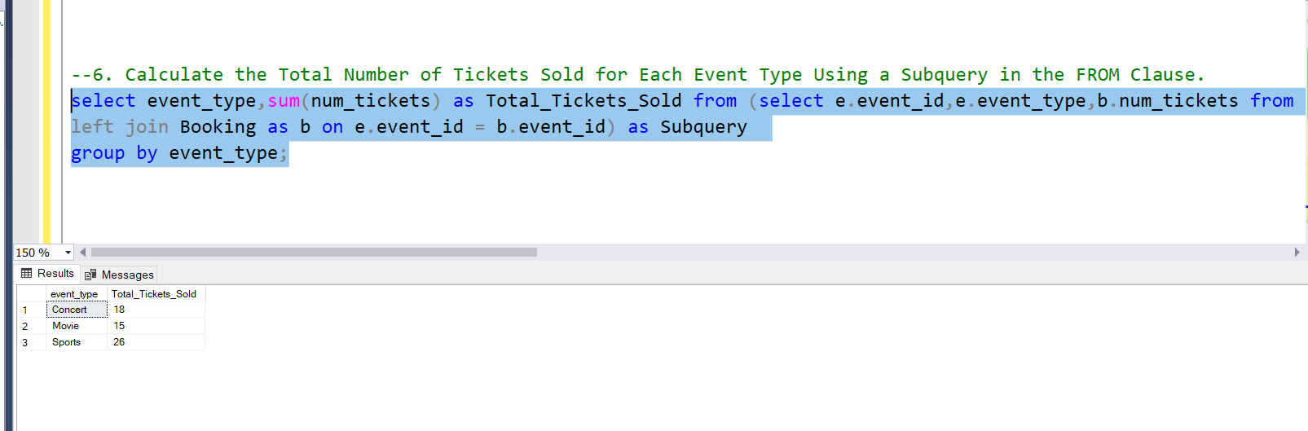

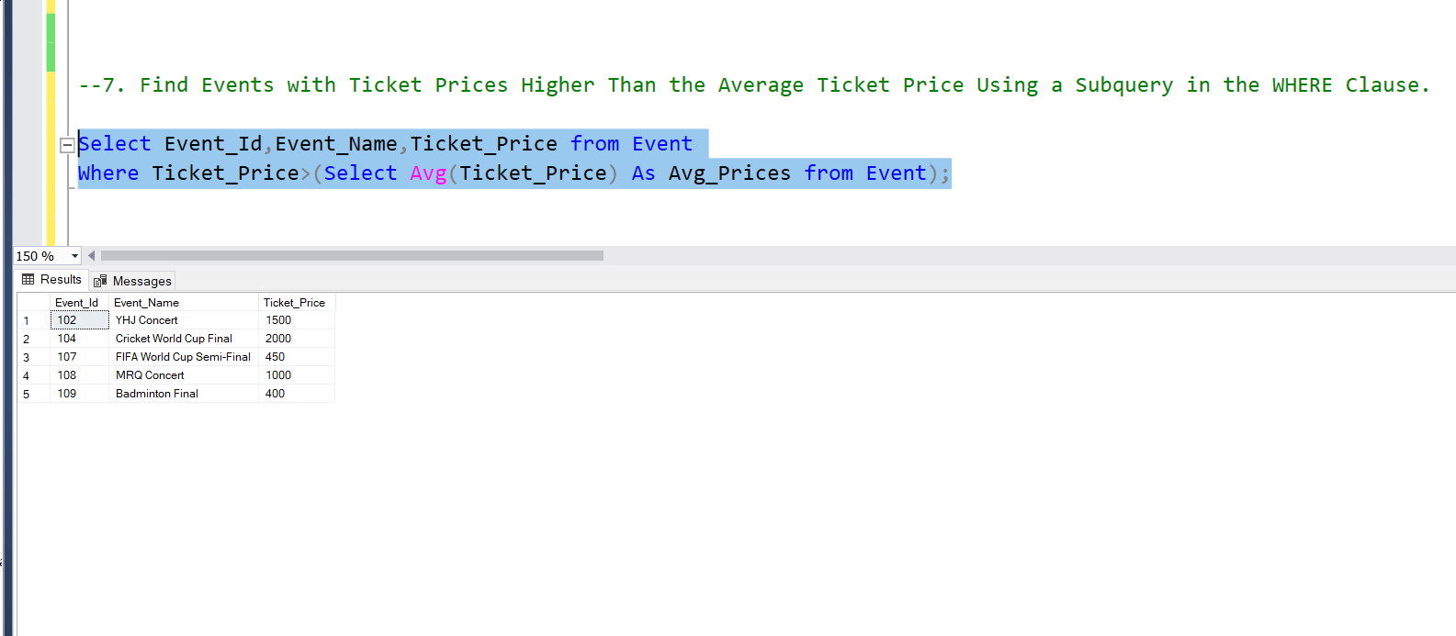30) Find Events with Ticket Prices Higher Than the Average Ticket Price Using a Subquery in the WHERE Clause.

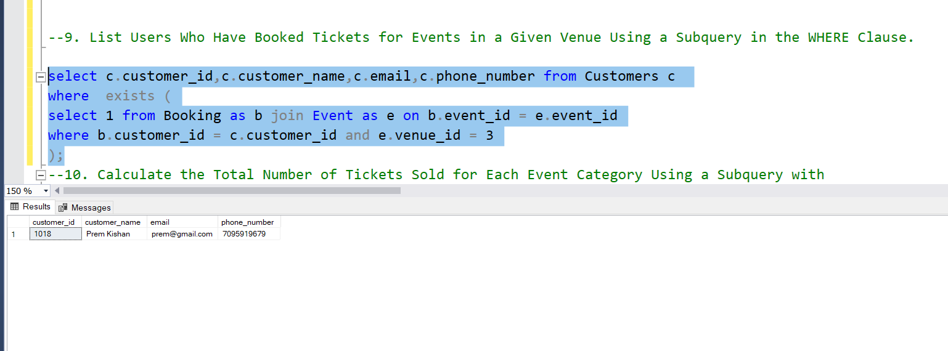31) List Users Who Have Booked Tickets for Events in a Given Venue Using a Subquery in the WHERE Clause.

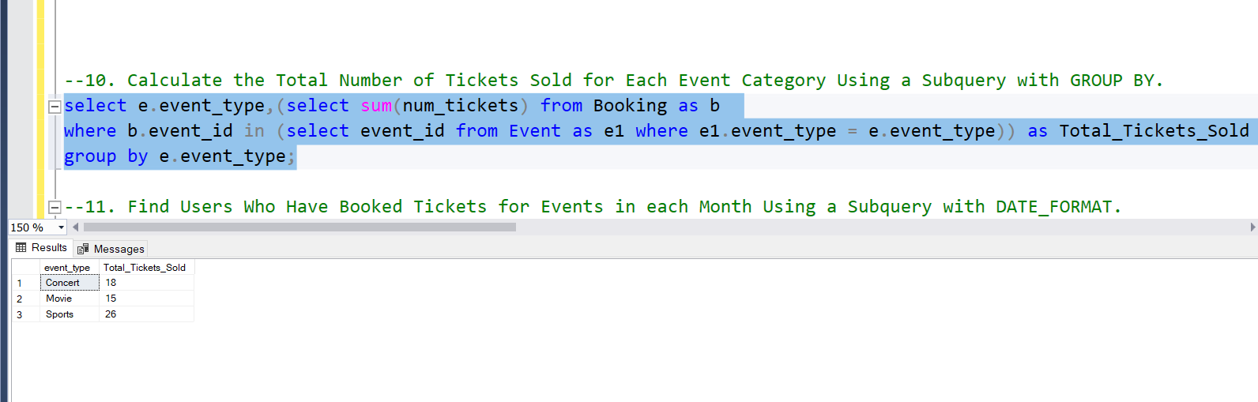32. Calculate the Total Number of Tickets Sold for Each Event Category Using a Subquery with GROUP BY.

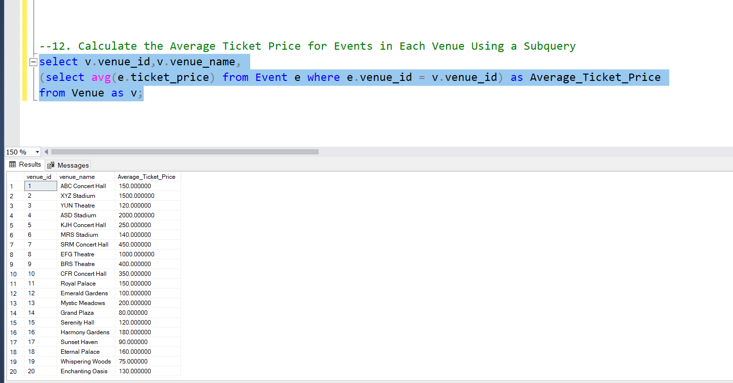33. Calculate the Average Ticket Price for Events in Each Venue Using a Subquery